Thoughts from a Dowsing Teacher

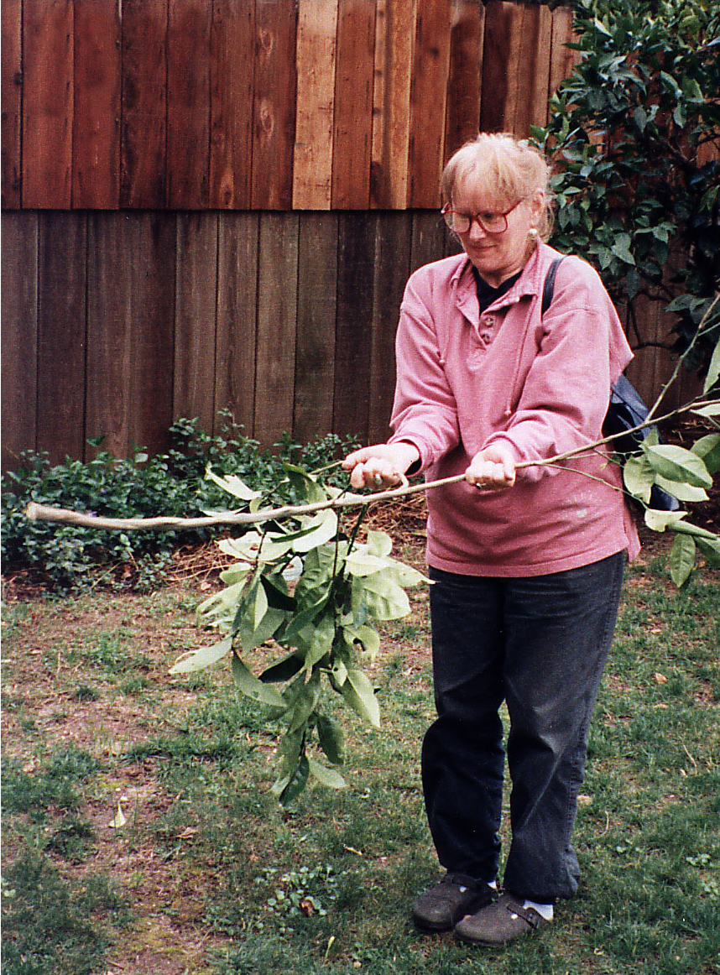

My grandfather, who was the local water dowser, taught me to dowse the summer before I went off to first grade. It was a beautiful Fall evening and the stars were just beginning to shine. My first question after determining my yes and no was, “Is there water on the moon?” I got a yes but didn’t quite believe it. Grandfather also got a yes so I was sure my dowsing must be working. I have never looked at the moon the same way since then.
In those days dowsing was used mostly to find water but on occasion when Grandfather and I were walking in the woods he would use dowsing to ask if a wild flower wanted to be in his garden. If he got a yes we dug it up and brought it home where it thrived in our yard.
At that time I had no idea what a gift he had given me.
I grew up in a household of teachers, Mom teaching school and Dad, a golf pro, teaching golf. It was natural for me to become a teacher as well. I studied visual art but have shared most everything I have ever learned and dowsing was no exception. I even taught my drawing students at Tufts University and my sculpture students at the Museum School in Boston how to dowse. As an artist it is important to know the truth about the work you are engaged in. Simple things such as: best color to use or ways to solve design flaws, shows and competitions to enter, the best gallery to show your work. Dowse, “Are they reputable? Will they represent you well? Can they advance your career as well as sell a few works of art? Will they pay you in a timely manner?” More importantly, “Is this really what I want to do with my time? Will this make a difference to the world I live in and to me?”
There is no end to the uses for dowsing, but most important of all, if you can dowse you will always be free. “Know the truth and the truth will set you free”. With dowsing you can always know the truth.
As you can see this line of yes/no questioning can be applied to most any endeavor: be it starting a business, moving, applying for a job, buying anything, taking a trip, voting for or running for any public office, or starting a new relationship. I am sure you can add a long list of what you might want to know.
One of the beauties of dowsing is that you need only know the question for the answer lies where the question is asked. Through dowsing you can find the answer. It is a skill we improve over time but it is also an art, a way of life as is integrity, gratitude, generosity, and happiness. Because we are human we will make mistakes and the best way to handle them is to learn from them. Do investigate your answers. Dig that well, check that archeological site, find that missing object, and go to that movie. If you are off, do your best to discover why. If you have charged a client for your dowsing, return your fee. Your integrity is most important.
I have always felt the more you know about something the better. I wanted to know how dowsing works so I began reading everything I could find on dowsing. Unlike today, there were few books on dowsing when I began my search. I explored fields as diverse as art, religion, physics, sacred geometry, ancient wisdom, geomancy, and ancient sacred sites. I also began observing others and myself as we dowsed. The following is my theory of how it works. It is not the only way of thinking, but if it works for you, please use it.

How Dowsing Works
Every human is surrounded by a life force often called an aura or spirit. It is everywhere and every when and encompasses all there is. Perhaps even is all there is. The subconscious mind, unlike the conscious mind, does not judge or evaluate, but connects directly to the aura through our chakra system. All chakras open to the aura but the Heart chakra is the one I like to dowse from most.
Our aura consists of seven levels, each having seven layers within it. The first level is about an inch thick surrounding our entire body. I call this our intimate space. As a child, I first noticed this hazy, white glow around people in the movie theater as the lights were dimming. The second level extends out about eighteen inches to three feet. It can actually be seen as having different colors and is the level that most dowsers measure. This is our personal space including closest friends. The third one is measured in miles and usually extends over one thousand miles in all directions. This could be thought of as our communal space or family, clan, and nation. The fourth level would encompass the Earth and the Moon and our conscious acceptance of being Earth creatures. This was brought home to us when we put a man on the moon for the first time. The fifth includes our Solar System and the sense of belonging to the universe. The sixth goes to the furthest visible speck of light reminding us of the wonder of being human. The seventh includes all there is-known and unknown-Oneness.
When given a yes/no code on dowsing tools and through subtle movement of the muscles the subconscious mind can inform the conscious mind of answers it might not be able to find any other way. The subconscious mind also regulates the inner functions of our physical body such as heartbeat and breathing and does everything it can to keep us healthy and happy.
Our conscious ego mind is a powerful focusing device, but it is not directly connected to our aura or spirit. It only receives selective information from our spirit through intuition, imagination, dreams, inspiration and bodily reactions such as goose bumps and hair raising up on the back of your neck. It does not know what it does not know. Because the conscious mind is not connected to the aura it cannot truly dowse. When specific, detailed questions are asked by the conscious mind, the higher self, which hears all our thoughts, will look through out all there is and report the answer back through the subconscious system. Dowsing gives the most direct and precise answers to yes no questions. Thus you can see it is important to ask very specific questions.
Mistakes in dowsing are usually a result of poor questions or faulty interpretations of the information received. Be weary of anyone who brags about their dowsing skill or claims 100% accuracy. I have never heard a true master call himself, or herself a “Master”.
If you do not like the answer you get, simply say “thank you” for the response and do what you choose to do. Do not try to have your dowsing agree with you or you will be teaching your subconscious to lie to you. After all one of its main jobs is to please. You must choose what you do with the information received. There is no loss of free will here, nor any absolution of personal responsibility.

Teaching Dowsing
The National ASD Convention, held each June in VT, always has a two-day beginning school that covers all you will need to become a fine dowser. If you can, do come to the Convention. However there are many excellent dowsers willing and eager to share their dowsing skill with you. Go to a local dowsing chapter as most of them teach the rudiments of beginning dowsing before their meetings. Check out the ASD web site (www.dowsing.org) for locations. Or call the headquarters (802-684-3417) and ask for more information. If you join the American Society of Dowsers you will have access to the members’ page where you will find all the quarterly journal articles ever written. Check out the ASD Book and Supply for amazing tools and books on the subject.
So how do I teach dowsing?
The American Society of Dowsing Convention and School that I attended back in 1986 opened my eyes to the vast possibilities for dowsing and also showed me that there were almost as many definitions and ways of dowsing as there were dowsers. Some were so complicated they made my head spin but the best dowsers seemed to keep to the simplest principles. So I use the simplest methods possible. If it works use it!
Like most arts it is important to be in a good frame of mind when you dowse but it need not be complicated. First do not be trying to prove anything or have your ego involved in the answer. Second, I have found that distractions are the usual cause of mistakes so focus your attention like a laser. If someone is distracting you, politely ask them to leave, or dowse at another time. The next big flaw is usually in the question itself. It is simple and precise enough? Am I asking more than one question or are the questions coming faster than I can dowse? We are human, and although we strive for 100 % it is rare indeed. So slow down and be as precise as you can. Know that anyone can dowse. It is important to remember that your ego cannot dowse for when you are ego involved in a question or quest, the answers will seldom be accurate. In such cases I recommend you ask someone else to dowse for you.
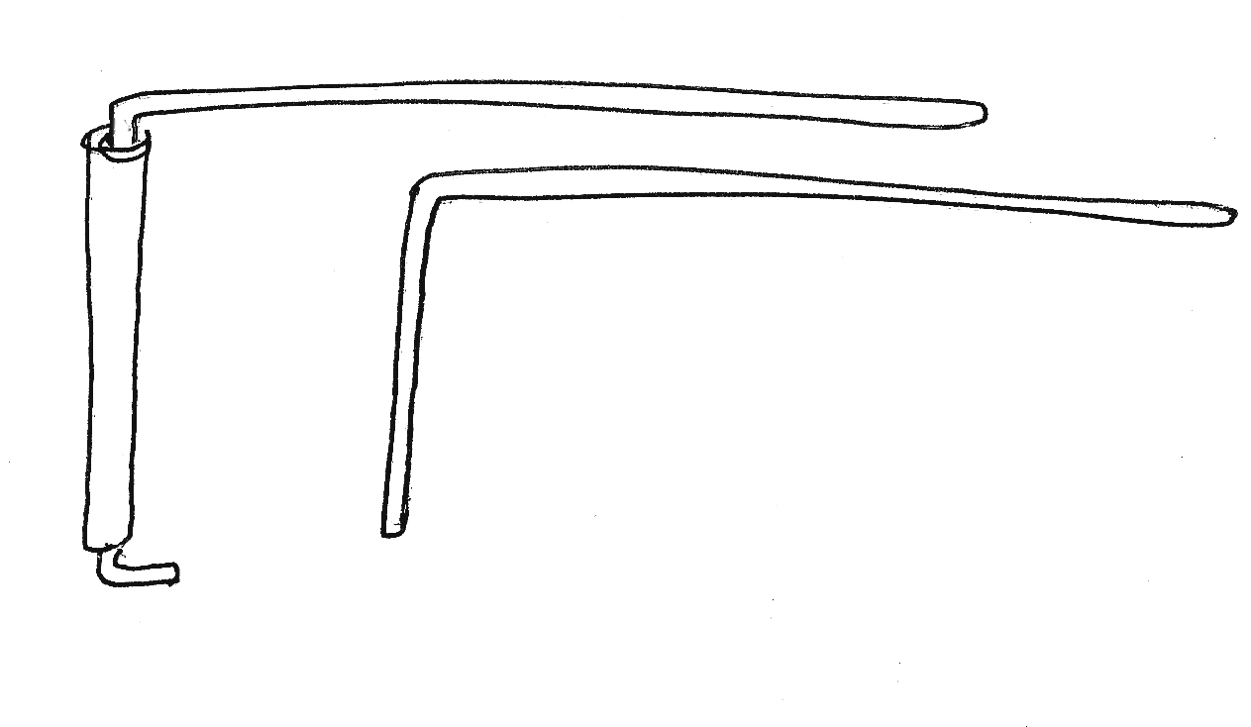L-Rods

When teaching I always start with the L-rods for I have never met anyone who could not get a response using them. Hold them parallel to the ground, about waist height like six shooters, and then ask what Yes looks like for you. The rods will swing either open or crossed. Sometimes the rods just keep spinning. Be patient. It is just that your higher self is excited that you are finally going to be able to listen to him/her. If you need to, tip the ends slightly down to calm them. Once you get your Yes response than ask for No. This will be the opposite of the yes. Most of us do not like hearing no but remember that without a good strong no your yes does not mean anything. Do not be influenced by the “expert’s” response. Once given your personal code you can now get answers to any simple yes/no question. It is most important to respect and honor everyone and everything. Do not ask questions if the matter is none of your business or does not affect you in any way.
If you are dowsing on site or in the field, the L-rods can point toward what it is you are looking for. They will swing toward North if that is what you ask for. They may also have a different response when you reach your target. Some dowsers get their yes response, others will get an “X marks the spot” so their rods will cross when over the target. What ever you get is fine just know your own responses and do not change them. You do not want to be confused when a real need arises.
The dowsing system, when taught well and practiced with integrity, allows the higher self to communicate with the conscious mind. It also avoids much of the normal ego censorship of ideas. Your inner voice, however, is quiet compared to the Ego’s loud one and often it is difficult to tell the difference. Over time, physical evidence that confirms your dowsing reactions helps to tame any nagging doubt. I suggest you practice on tangible goals so as to verify your results. Practice, practice, practice… but, you may discover that once you can consistently find the coin or get the right color of the turned over card, your higher self will quickly get bored and you will no longer get accurate answers. You no longer have a need to prove to yourself that you can dowse so it is time to get down to business. Dowse real questions and start using dowsing to make a difference. Continue to explore and investigate and learn and be delighted.
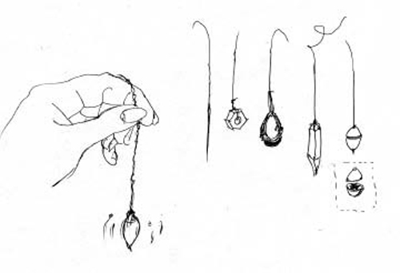 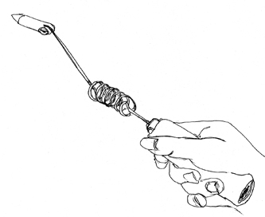 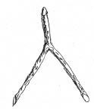 Pendulums Aura Meter Y-Rod 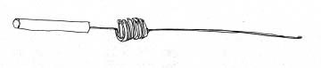
Bobber

There are many tools that you can use. Some are very complicated, expensive and beautiful like the aura meter and some pendulums, but here too you can use a branch from a tree or any simple weight tied to a string such as your keychain or even a wet teabag. Simple, simple, simple! When choosing another tool, begin as you did with the L-rods by asking your higher self to show you your yes and no responses. Just remember that the tool does not do the dowsing - you do. Just as a pen only writes when you move it and any pen will do. You may find that different tools seem to feel better for different situations. I usually use L-rods for field dowsing, the pendulum when advising on the phone, body-dowsing in the grocery store, as L-rods are far too obvious. When walking in the woods a long thin stick that bobs will do.
Water is one of the most precious targets you will dowse for. There are many questions to be asked when dowsing for water so it is best to consult with a good water dowser or read their articles and know the laws of the State in which you are dowsing. The same is true for any subject you choose to pursue. The more you know about the subject the better questions can be asked and the better dowser you will be. Questions and how they are asked are most important as you get exactly what you ask for. I once asked my rods to show me the shortest route through the woods to my car. Ask for the safest, not the shortest route, as climbing down cliffs or walking on water is not what you intended.
Know that your dowsing will become more refined as you continue but do not hurry and keep it simple. One amazing success does not make us a master.
All this is pretty daunting even for a seasoned dowser. Learning to trust is perhaps the most difficult aspect of being a dowser. You will get answers you never expected so do not be surprised. Know also that it is not your job to fix everything you find needing fixing. Do what you can and move on. Even though you will find that healers use dowsing in their practice do not practice medicine without a license! This is against the law and will be prosecuted.
To conclude, I hold that all things are alive and intelligent. Dowsing allows for profound communication with all living, conscious beings, including plants, animals, water, rocks, the Earth, and the spirit world of, angels, divas, gnomes and other unseen beings. Aside from the kinship with all living things, the benefit I find most rewarding is the freedom it engenders and the creation of a means of direct communication with my higher self or spirit. Every time we dowse we are building a bridge to our higher, spiritual self.
I never cease to marvel at the wonder of it!

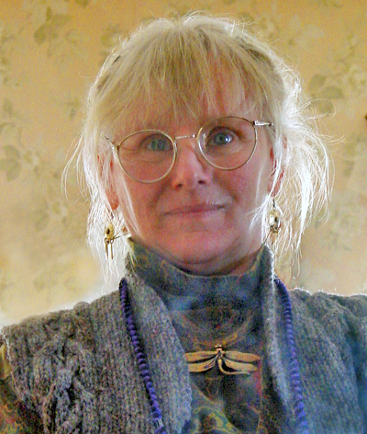
Marty Cain
www.martycain.com
martycain@protonmail.com
828-545-0023

